AWS Task-1

Task Description:

Create a windows Vm machine in AWS and connect with RDP open CMD in windows share the about system info.

Techstacks needs to be used :

- AWS EC2 (windows)
- RDP (Preavailable in Windows)

Steps:
- Configure the EC2 Instance:
  - Set up a new EC2 instance, selecting the Microsoft Windows Server Base 2025 AMI.
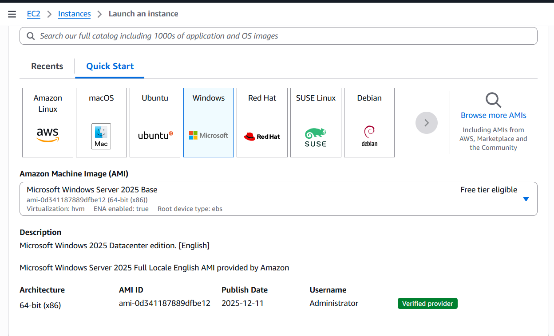
- Select Key Pair:
  - Choose an existing key pair or create a new one to secure the instance.

- Configure Network/Security:
  - Ensure that the security group (firewall) settings allow RDP (Remote Desktop Protocol) traffic to reach the instance.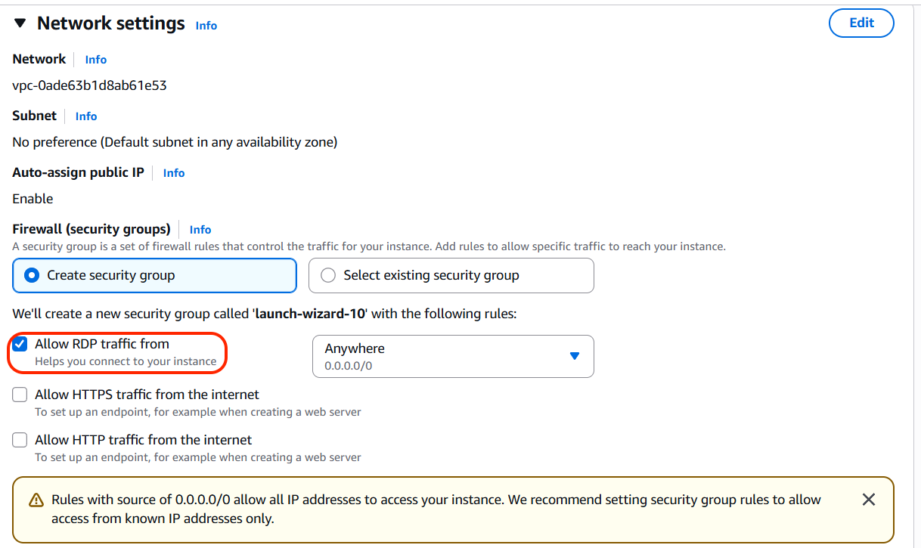
- Launch and Connect:
  - Launch the instance.
  - After the instance is running, select it and click Connect.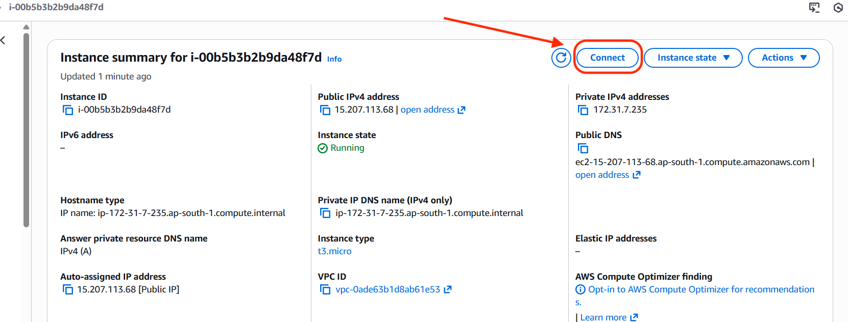

- Retrieve Password:
  - Under the RDP client tab, click Get password.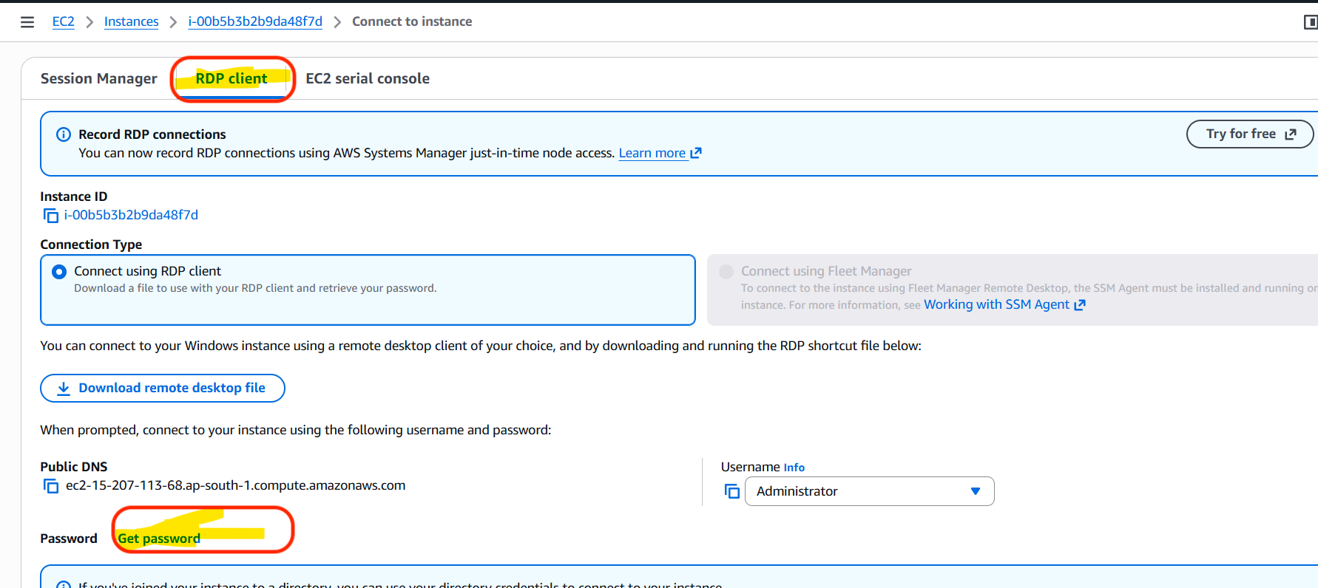
  - Upload the private key (.pem) file associated with your key pair.
  - Decrypt the file to reveal the administrator password.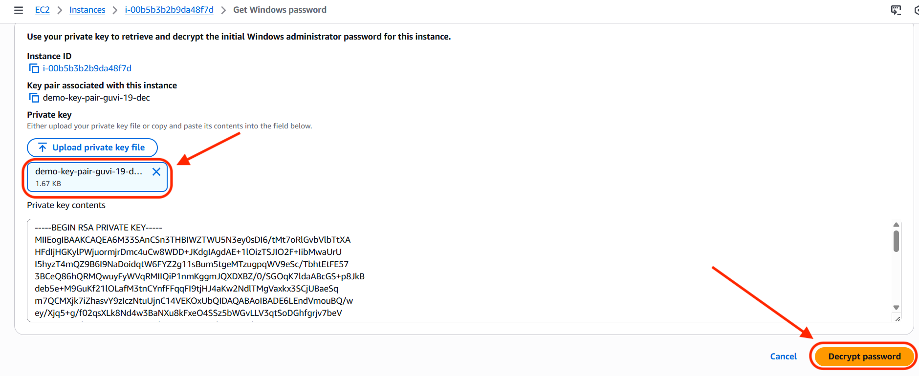

- Establish RDP Connection:
  - Click Download remote desktop file and open it.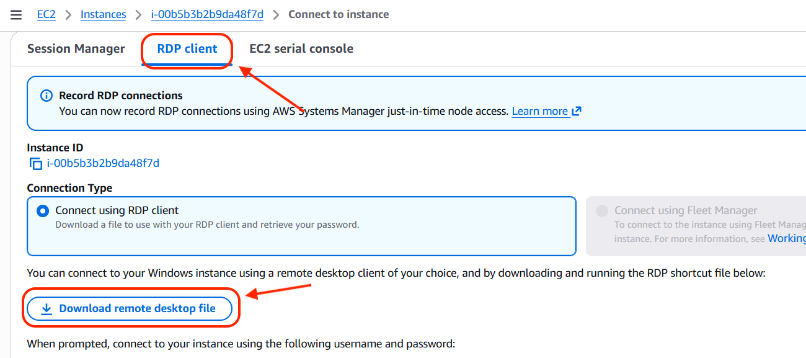
  - When prompted, use the decrypted password and the provided username (typically 'Administrator') to log in and click on connect.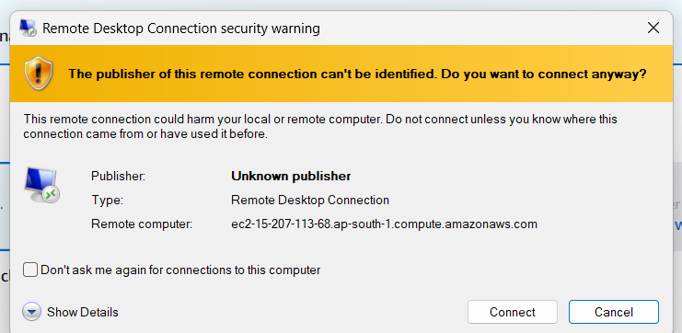

- Gather System Information:
  - Once connected to the Windows VM via RDP, open the Command Prompt (CMD).
  - Type the command systeminfo and press Enter.
  - The command output will display the detailed system information for the EC2 instance.
